**CHAPTER 01**

**INTRODUCTION**

This project is an advance approach of changing the physical gesture of hand into the electrical signal and then to process that signal into digital signal of appropriate magnitude and to be transmitted through the transmitter. This paper provides an instrumental solution to the people who have difficulty in moving or their body part has paralyzed, or they have lost their limb in an accident. This wheelchair is going to bring a paradigm shift between man and machine. Where this machine will be working on the user commands, we can also say its human machine interface. With the growth of technology there has always been an effort to use the technology for the betterment of mankind. Time and again the technocrats of the world had proved their metal in bringing the comfort to the people who are in need with the help of technology. Bringing the technology and economy parallel to each other is paramount aim of this paper. Also to build a Hand Gesture Wheelchair which has sound technology but low in cost is the primary concern. Today in this modern era around worlds 10 percent, around 650 million people are suffering from physical disability. In order to make their life bit easier we decided to make a hand gesture controlled wheel chair which will be working on the gesture of their hand. The wheel chair is wireless and has a range of 200 yards. It means a person can control his wheelchair from 200 yards away. He can call his chair while sitting from one place irrespective of weather conditions. The disabled people always find difficulties in moving from one room to another and even to do that the handicapped person was dependent on someone else who will push the wheelchair manually and take the handicapped person from one place to another. Now with the Hand Gesture Controlled Wheelchair the handicapped person is independent and he need not to ask for help from any other person to move his wheelchair. Just with the movement of his hand the handicapped person is able to move from one place to another without needing anyone’s assistance which also makes him self-dependent.

**CHAPTER 02**

**BACKGROUND**

The percentage of disabled people has increased in both rural and urban part of India. The disability could be by birth or due to some medical or accidental reason. The aim of this paper is to make a hand gesture controlled wheel chair using accelerometer as sensor to help the physically disabled people in moving from one place to another just by giving direction from the hand. Today in India many people are suffering from disability, there are people whose lower half of the body is paralyzed. This Wheelchair will add on to the comfort and make the life of people bit easier. Around 5436604 people are affected from movement disability. Percentage of population which suffers from different disabilities is shown in graph below. Out of total disability maximum people suffers from disability in movement.

0.00

%

5.00

%

10.00

%

15.00

%

20.00

%

25.00

%

Multiple…

In hearing

In speech

In movement

Mental…

Mental…

Any other

In seeing

**Percentage**

Percentage

***Fig 2.1:*** *Percentage of people suffering from different kind of disability.*

**CHAPTER 03**

**PROBLEM DEFINITION AND SCOPE**

Benefits to people who are:

* Paralytic people.
* Those who crawl.
* Those who walk with the help of aid.
* Those who have acute and permanent problems of joints/muscles.
* Those who have twisted body parts and suffer from any kind of deformity in the body.

**CHAPTER 04**

**PROJECT PLAN**

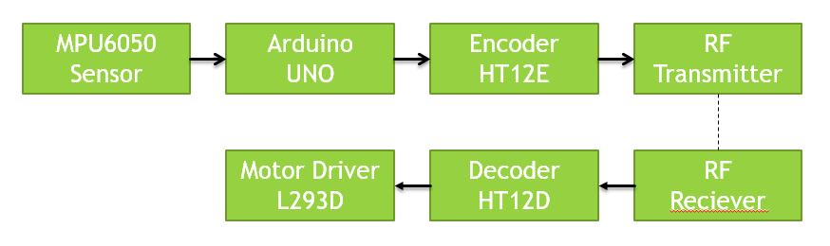

***Fig 4.1:*** *Project flow and plan.*

**CHAPTER 05**

**DETAILED DESIGN**

In this Hand Gesture Controlled Wheelchair an MPU6050 Accelerometer + Gyroscope is used as a sensor which will be giving analog signal on moving it in X, Y, Z axis respectively. An LM324 operational amplifier is used as a comparator to convert the analog signal into the digital signal. Radio Frequency transmitter of 434 MHz frequency is used to transmit the signal wirelessly. Before sending, the data is encoded with an encoder IC HT12E with secured address so as to avoid its interference from other device. After that the signal is sent wirelessly. Now the receiver receives the signal and then it is processed through decoder so as to decode the signal further the data received through receiver is sent to microcontroller as an input.

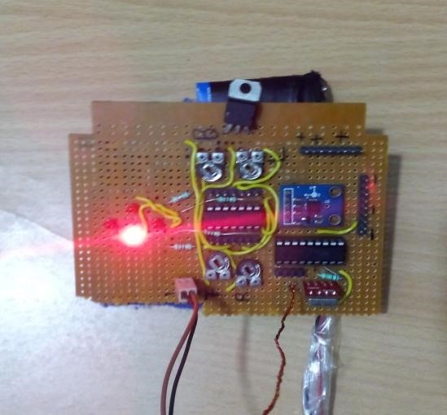

***Fig 5.1:*** *Hand gesture circuit with accelerometer and transmitter.*

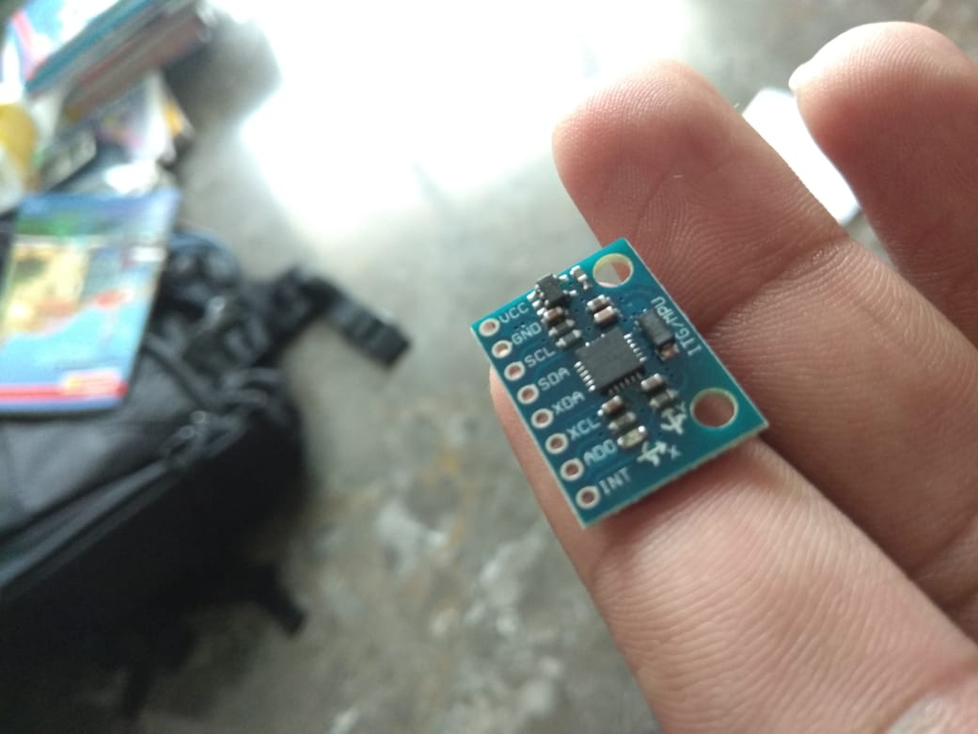 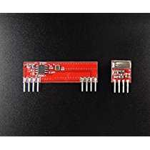

***Fig 5.2:*** *MPU6050 and RF transmitter and receiver.*

On receiving the input the signal the microcontroller compares the data which is preinstalled in the controller. If the input data matches the preinstalled data then the signal is given to L293D IC on receiving the signal the L293D IC gives the signal to relays and then the wheelchair starts moving. We chose MPU6050 accelerometer + gyroscope as the sensing device because it records even the minute changes. The first challenge is to calibrate the accelerometer according to the needs of project so that we can precisely control the motion of wheels and for that we use variable resistors and check the output for different values of voltages which we changed by using variable resistance. We use comparators to compare the two inputs and give the result accordingly. We also have to adjust the tilting angle as per the motion of hand.

After taking various values we set the reference values of the comparator as:

***Table 5.1:*** *Reference Voltages.*

|  |  |
| --- | --- |
| **Direction** | **Reference Voltage** |
| Forward | 1.15 V |
| Backward | 1.92 V |
| Right | 1.85 V |
| Left | 1.76 V |

**CHAPTER 06**

**IMPLEMENTATION AND RESULT**

**APPLICATION SNAPS/RESULTS**

When both the wheels of wheelchair rotate in forward direction then the wheelchair moves in forward direction. When both the wheel rotates in reverse direction then the wheel chair moves in backward direction. When left motor rotates and right motor shaft is stationary then the wheelchair moves in right direction, and when right motor rotates and left motor is stationary then the wheelchair moves in left direction.

|  |  |
| --- | --- |
| **Components** | **Input voltage supplied** |
| Motors | 24 volts |
| IC7805 | 11.91 volts |
| IC 7812 | 11.91 volts |
| MPU6050 | 4.90 volt |
| LM324 | 4.90 volt |
| HT12E | 4.90 volt |
| Transmitter module | 4.90 volt |
| HT12D | 4.96 volt |
| Receiver module | 4.96 volt |
| 89S52 micro controller | 4.96 volt |
| L293D | 11.91, 4.96 volt |
| Relays | 11.91 volt |

***Table 6.1:*** *Components and input voltage supplied to them*

|  |  |
| --- | --- |
| **Movement of wheelchair** | **Threshold angle of hand gesture** |
| Forward | 30 Degree forward |
| Backward | 30 Degree backward |
| Stop | 0 Degree |
| Left | 30 Degree left |
| Right | 30 degree right |

***Table 6.2:*** *Threshold angle of**hand gesture.*

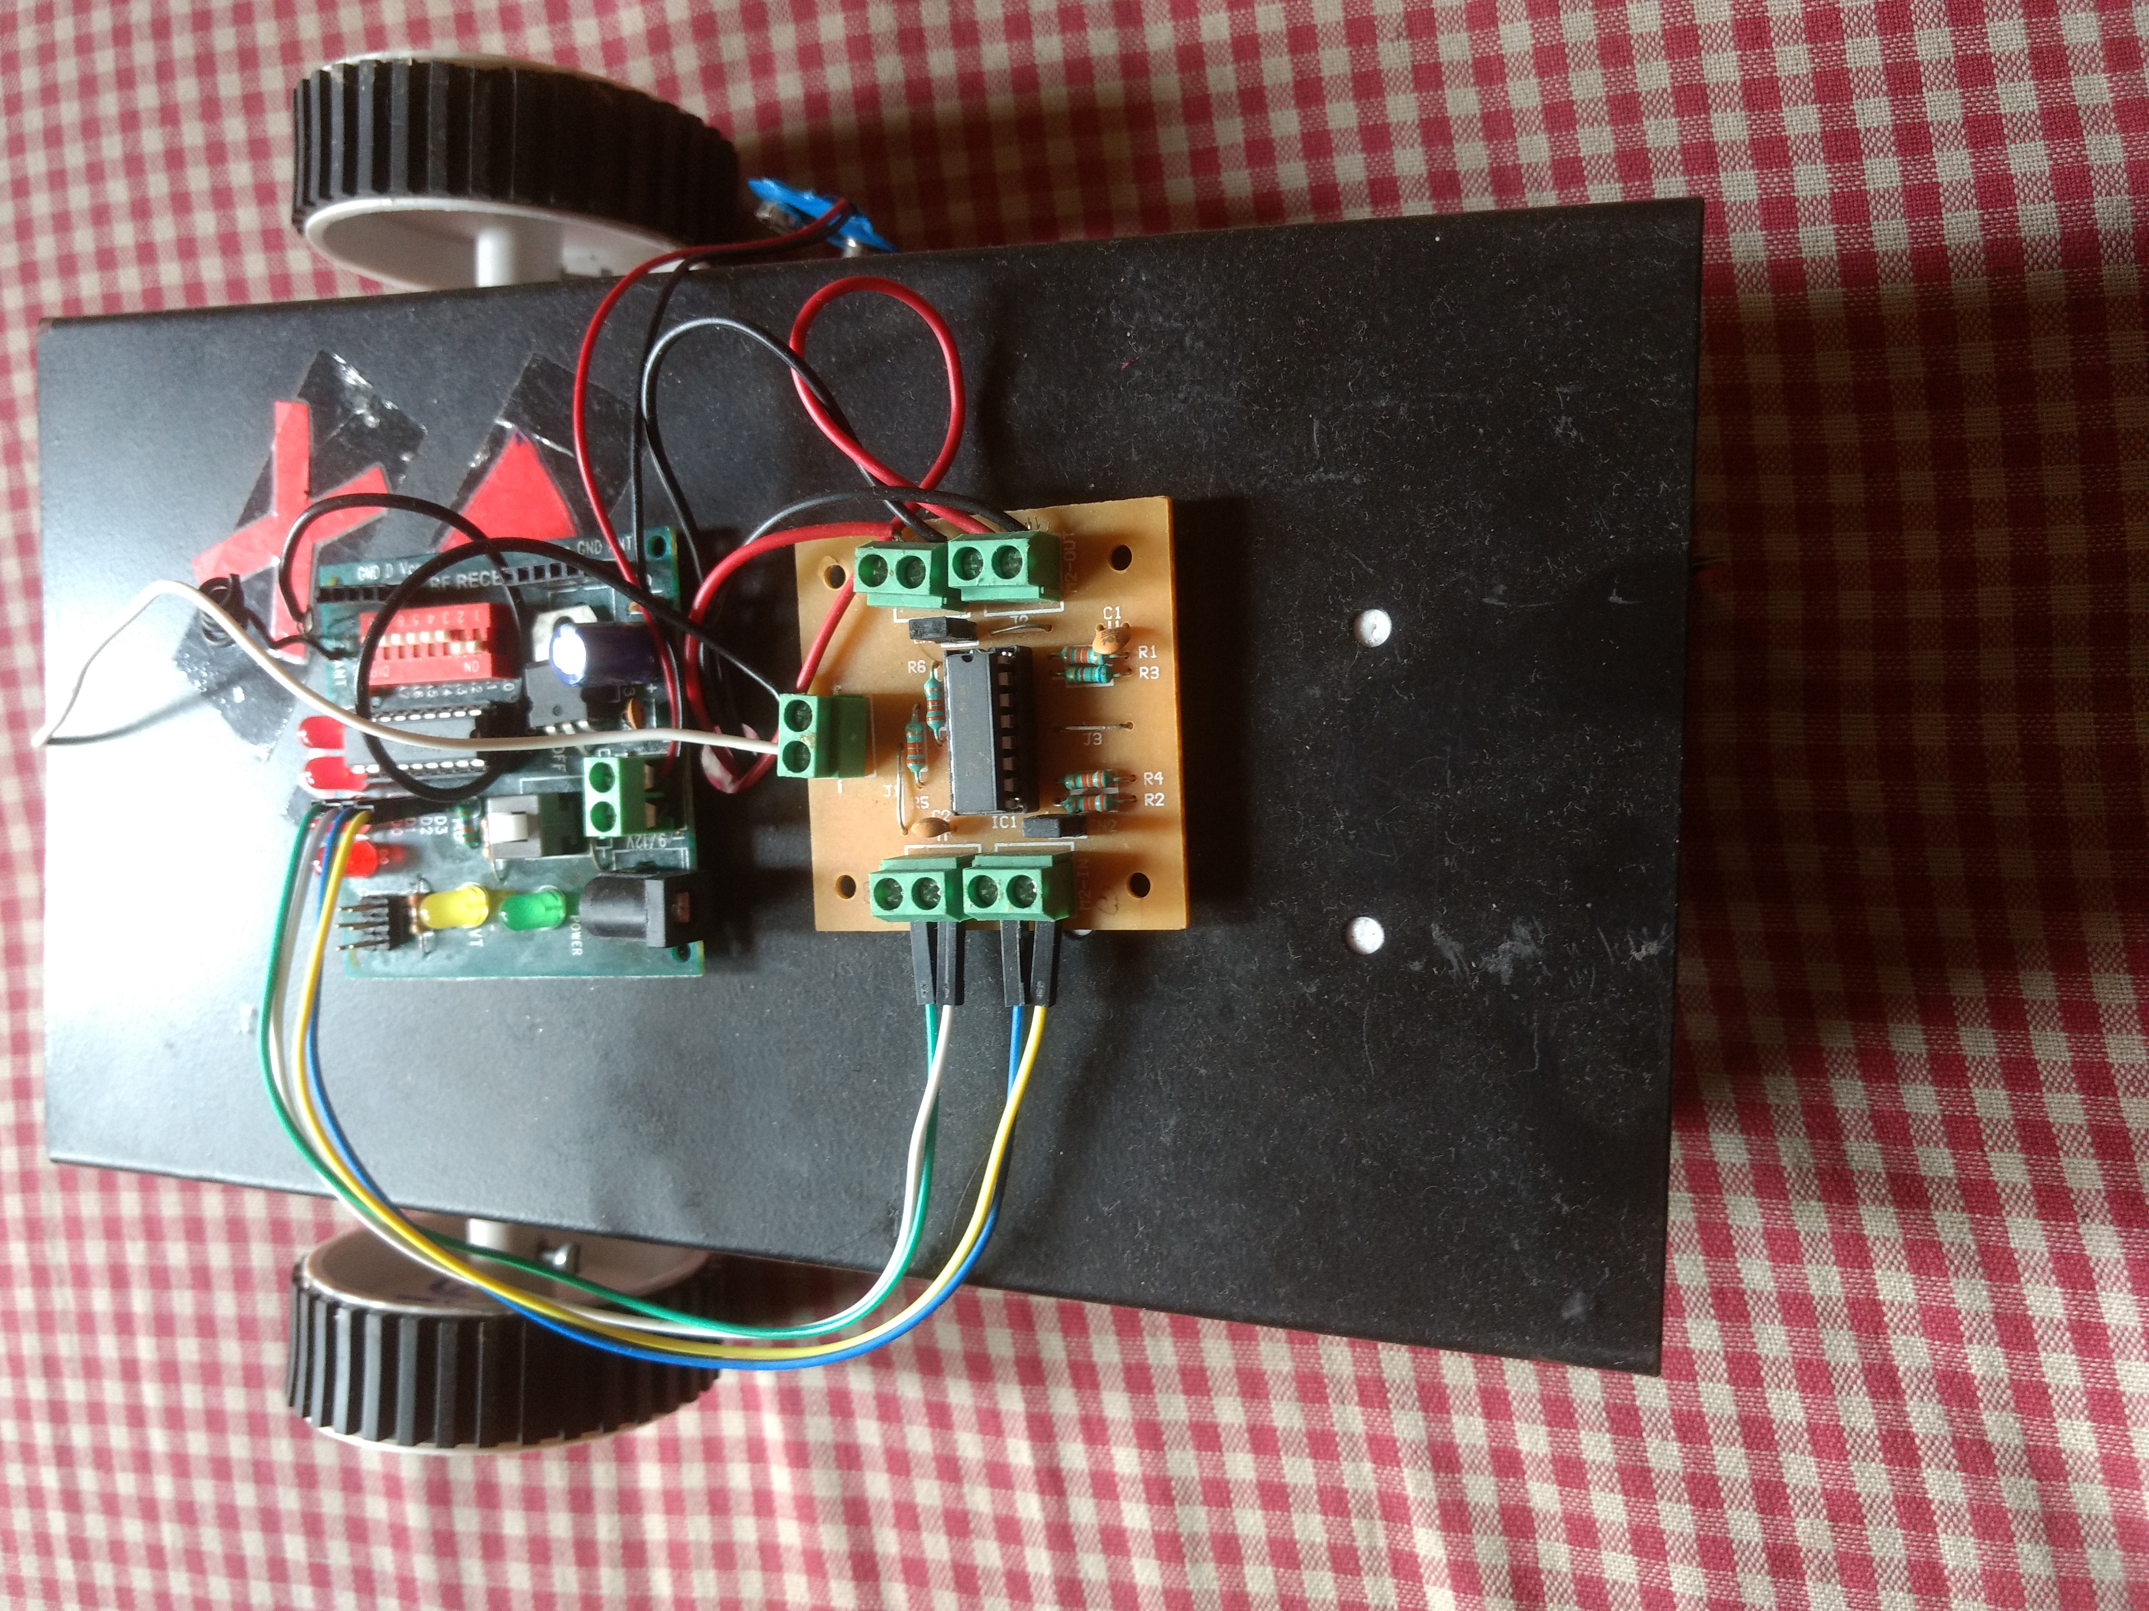 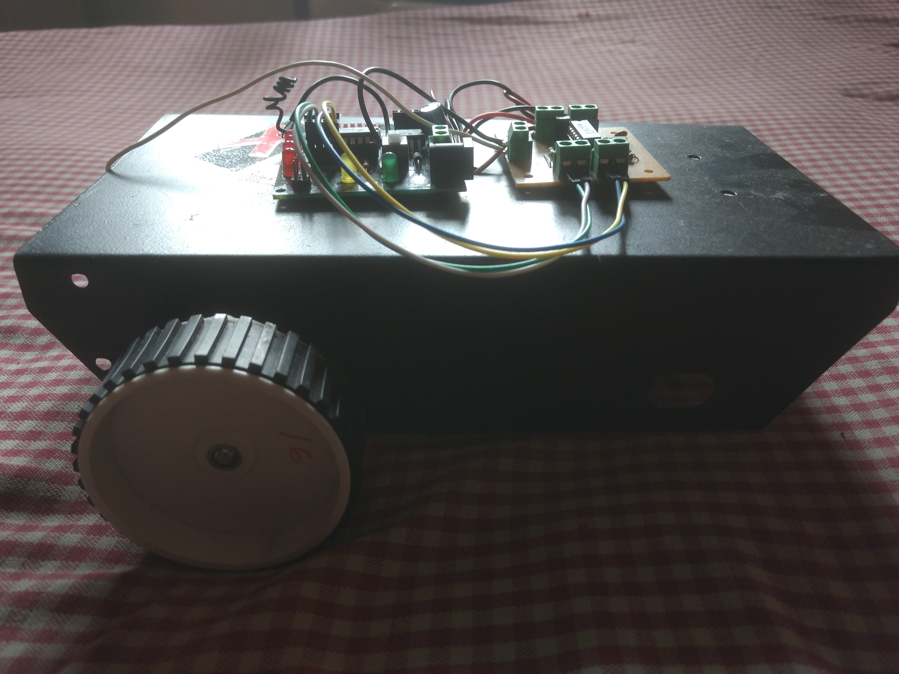

***Fig 6.1:*** *Prototype.*

**CHAPTER 07**

**CONCLUSION AND FUTURE ENHANCEMENT**

**Conclusion:**

The wheelchair is fully capable of carrying the load up to 110Kg, and moving in accordance to the gesture given by the person who is using the wheel chair. Certain improvisation and improvement can be done to make the wheelchair more reachable to those whose whole body is paralyzed. Certain eyes gesture or brain signals reader can be imparted on the wheelchair system so as to make it better.

**Future Scope:**

The hand gesture wheelchair has the ability to bridge the gap between man and machine. Further this hand gesture can be changed to speech and brain signal recognition which will be a battle winning factor for all those people whose whole body is paralyzed. We can further improve wheelchairs by making it with low cost and high accuracy which are operating by a wireless remote with various different sensors. An array of sensors can be used and integrating the inputs of multiple sensors and then processing them. Further safety features can be added into the wheelchair like implementation of ultrasonic sensor for the object detection. GPS system can also be implemented to know the exact location of the person who is in wheelchair and by using GSM module an SMS can be sent to pre-defined number in case of emergency.

**Bibliography**

1. Amundson JS, Amundson SG, “A joystick controlled wheelchair”, Biomed Sci Instrum .1991; 27:131-3.
2. Amundson JS, Amundson SG, “A joystick controlled wheelchair”, Biomed Sci Instrum .1991; 27:131-3.
3. Mahaboob Ali Shaik M.Prathyusha, K. S. Roy, “Voice and touch screen based direction and speed control sof wheel chair for physically challenged using arduino,”